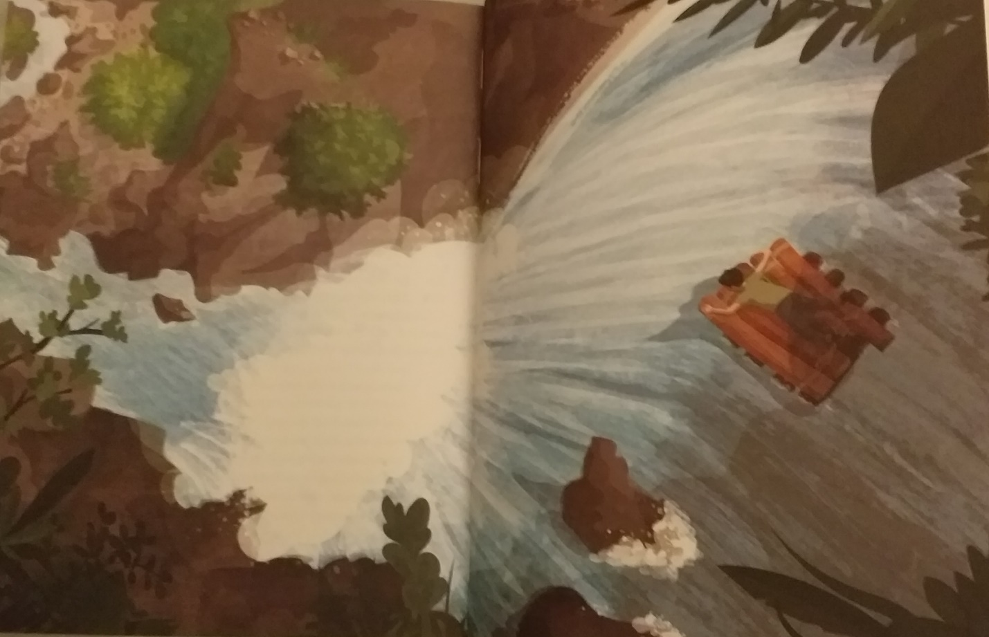
- Write a story using this picture as your inspiration. Although it is taken from the Survivors book, try to make your story something completely different.
- I have also included a link to a story plan to give you some reminders of what to include in your writing. Try to remember all the other things too like good use of punctuation and vocabulary as well as spellings and presentation.
- The deadline is for tomorrow so you should have plenty of time to create some brilliant writing.

