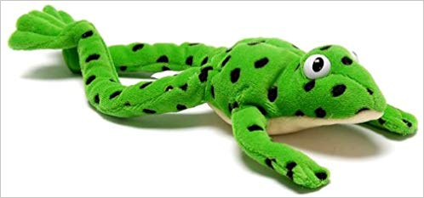
“Freddy Fingers”

In class we have started to orally blend sounds to start and read words. This involves breaking words down into their smallest units of sounds (phonemes).
With ReadWriteInc we use ‘Fred Fingers’ as a teaching aid for reading, which corresponds to a puppet called Fred the Frog who can only speak in sounds, not whole words. Fred teaches the children to use their fingers to break down words into their individual sounds to assist blending, reading and spelling. When children look at their own fingers, it allows them to visualise each sound of the word on a single finger.
For example:
a
t
m

m a t

Once you have assigned a sound to each finger, then you can say the sounds in order faster and faster until you can hear the word and then blend the three separate sounds m-a-t to make mat.
You can practise this at home using the sounds we have practised so far in class getting them to recognise and say the sounds (m a s d t i n p g) and make words (sad, pin, mad, tim, sat, mat, dim, gap, pad, pig etc.). This bank of sounds will continue to increase over time.
You can then use this technique when your child is reading words in their reading books that are phonetically decodable to aid them in reading. You can use this to promote independence in reading and use it for words with more than 3 sounds such as stamp.

