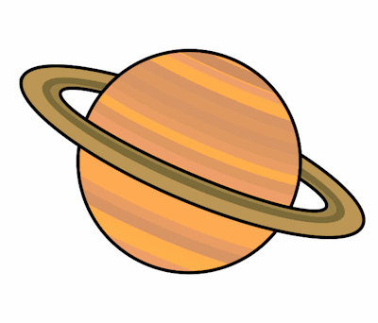
Planet Spellings
Week beginning 12th October
(Suffix -ly)
sudden
suddenly
careful
carefully
final
finally
humble
humbly
gentle
gently

