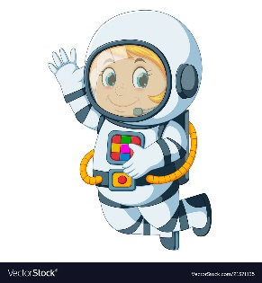
Astronaut Spellings
Week 7 18.10.21
no
know
new
knew
write
right
where
wear
great
grate

