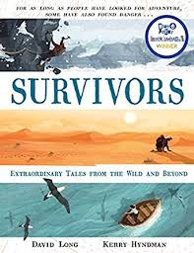
- Read from page 116, ‘The woman who froze to death yet lived,’ to the bottom of page 118, ‘…bringing the patient fully back to life.’
- Can you find 3 things that tell us something about where this survivor’s story took place?
- What did Anna’s friends do to help her?
- If you had been one of Anna’s friends, how would you have been feeling forty minutes after the accident?
- At the bottom of page 117, the author begins a new paragraph with, ‘By now…’. Why do you think he chose to begin a new paragraph here?
- Why do you think the author chose to go into so much detail about body temperatures in the paragraph beginning, ‘Still showing no sign of life…’?
- What facts does the author give that tell us this was, ‘no ordinary situation’?

