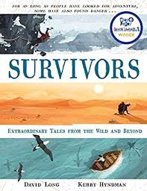
- Read page 52, ‘The man who sucked blood from a shark’ up to near the bottom of page 53, ‘…to the coast to shout for help.’
- Predict what you think will happen next. You can present your work how you like for example you could do little pictures with captions or you could write a report. It is up to you. I haven’t read on yet so I’m looking forward to seeing what you come up with!

