Virtual Sports Day

Wednesday 8th July 2020

Suggested programme of the day:

Reception and Key Stage 1 will be during the morning and Key Stage 2 will be during the afternoon

10:00am Welcome from Headteacher – please join us on Teams for this.

Reception and Key Stage 1 programme:

10:10am Sprint shuttle run
10:30am Target throwing
11:00am Dribbling run
11:30am Balancing slalom run

Key Stage 1 results should be submitted via the link below by 2:00pm

Reception and Key Stage 1 results link: https://forms.gle/i7fq11MKscxuihhz6

Key Stage 2 programme:

1:30pm Sprint shuttle run
2:00pm Target throwing
2:30pm Dribbling run
3:00pm Balancing slalom run

Key Stage 2 results should be submitted via the link below by 5:00pm

Key Stage 2 results link: https://forms.gle/n3p3q9zzNFy2812A6

Please take some photos and videos of your children taking part in their activities so we can create a video of North Stainley Virtual Sports Day and send them to: admin@northstainley.n-yorks.sch.uk

North Stainley
Virtual School Sports Day

Event 1

Sprint – shuttle run
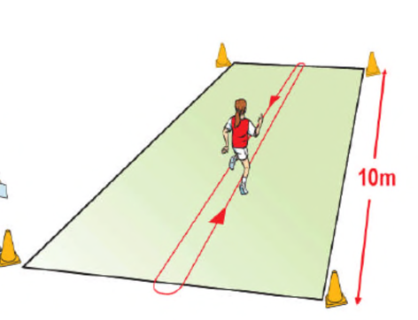
Rules
- Start behind the start line
- Run to the opposite line and ensure you place a foot over the line before you return.
- See how many shuttle runs you can do in 60 seconds
- If however, every time you didn’t step over the end line at the end, you don’t get your point for that length.
Body
- Ensure you plant that foot over the end lines and get low in your turn and then drive away.

Target Throw
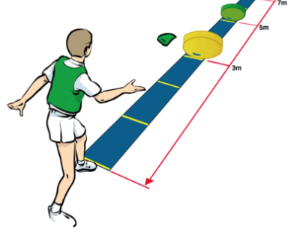
Rules
- The participant stands behind a line and throws three items into the target placed 3m. The target is then moved to 5m and the process is repeated.
Scoring:
- 4 points if the item lands in the target. 2 points if the item bounces out of the target or if the item touches the floor before the target
Event 2

Event 3

Standing Long Jump

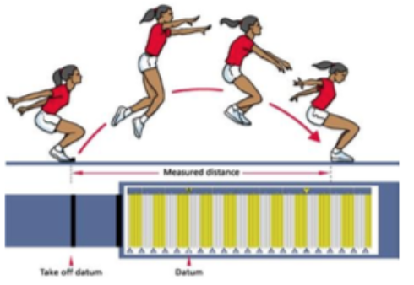
Rules
- The participant should stand behind a line and start from a standing position and jump as far as possible landing on two feet
- You should start on two feet and land on two feet.
- You are not required to hold the landing position but if you fall back or step back towards the jump, the jump should not be recorded – have another go!
Scoring
- Your score is your jump measurement.

Event 4

Balancing Slalom Run

Rules
- Start behind the start line with a tennis ball balancing on a spoon or racket.
- Slalom through the cones while balancing your tennis ball on a spoon or racket, when you get to the blue cone run straight back to the start line. Keep going for 60 seconds.
- See how many balancing shuttle runs you can do in 60 seconds
- Every time you pass the start line you get one point.
- If your ball drops of your spoon, just pick it up and carry on until your time is up.

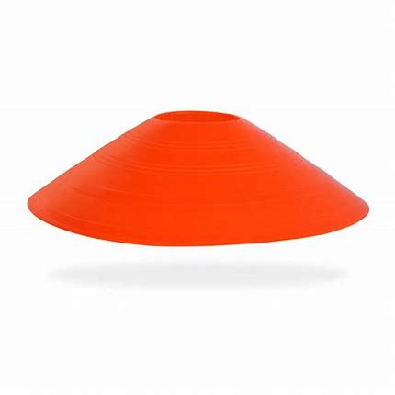
10 m
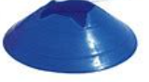

Equipment required

Events | Equipment required | Adapting equipment
Event 1
Sprint – shuttle run

Event 2  Target throw | 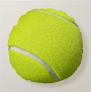 | Chalk
Event 3  Standing Long Jump |  | 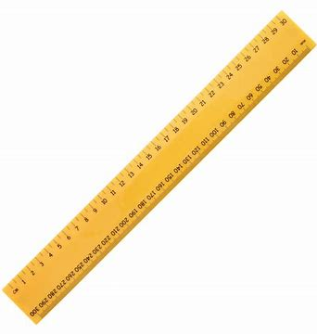  Ruler String Scarf
Event 4  Balancing Slalom Run | Recording sheet | 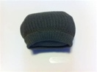  socks

Event | Practise | Final Score
Sprint shuttle run
Target throwing
Standing Long Jump
Balancing slalom run

Please submit your results by the following link:
Reception and Key Stage 1 by 2:00pm - https://forms.gle/i7fq11MKscxuihhz6

Key Stage 2 results by 5:00pm - https://forms.gle/n3p3q9zzNFy2812A6

