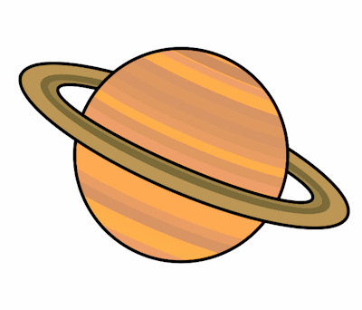
Planet Spellings
Week 8 1/11/21
serious
obvious
hideous
anxious
tremendous
jealous
enormous
glamorous

