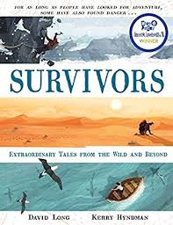
- Read page 177, ‘The adventurer who went over a waterfall,’ to the bottom of page 179.
- Why do you think Yossi Ghinsberg was desperately keen to explore the rainforest even though it had claimed the lives of thousands of people?
- How do you think he managed to find three other travellers prepared to go with him?
- Where do you think the men went wrong even before they set off on their adventure?
- What do you think the men might have had ‘clashes and disagreements’ about?
- Do you think the raft idea was a good one? Don’t forget to explain your answer by referring to the text.
- What does the author mean by the ‘tumult’ at the bottom of page 179?
- What do you think will happen to Ghinsberg next? How is he feeling?
- What about Gale? Do you think he will manage to find his way to safety?

