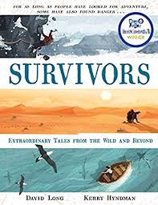
- Read from page 182 to the end of the adventure.
- Can you create a cartoon style account of Yossi Ghinsberg’s survival story?

