Dear Parents and Carers

RE: Christmas Dinner

School Christmas dinner was great fun, we had some of our Governors and school supporters join us and the children did a great rendition of Jingle Bells. A huge THANK YOU to all staff and Tash & Sarah for laying on a great feast and help all round.

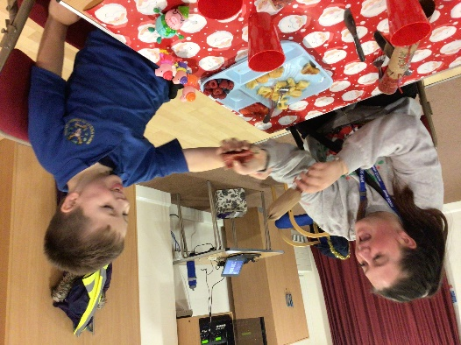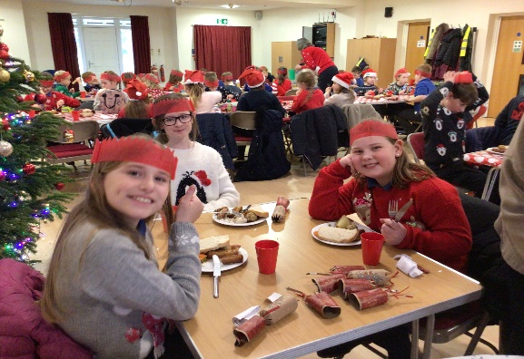
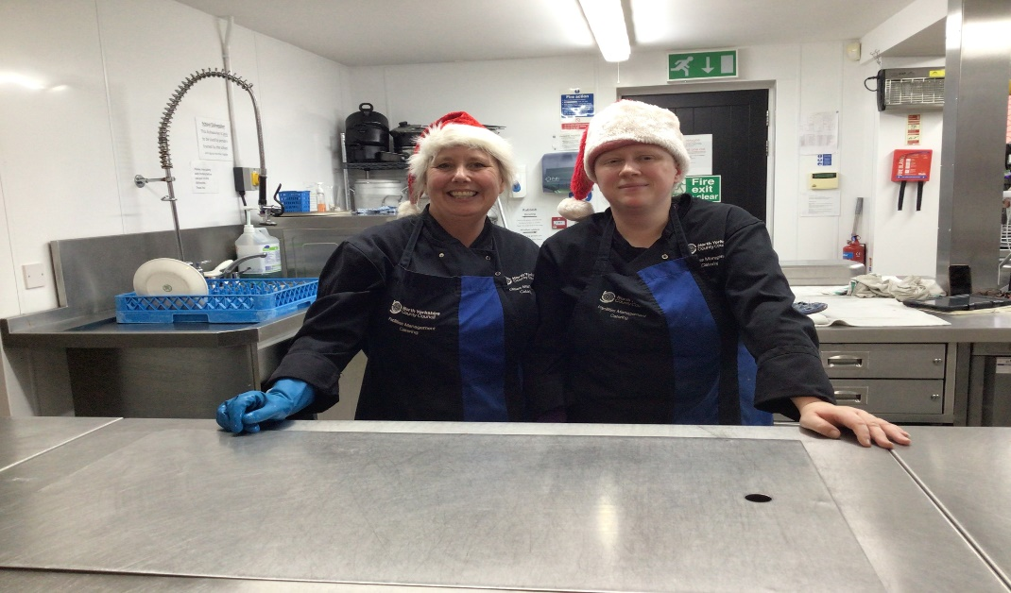

Kind regards

Louise Wallen

