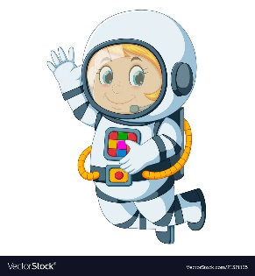
Astronaut Spellings
Week 4 24th January
clockwise
anticlockwise
septic
antiseptic
freeze
antifreeze
social
antisocial

