Key Vocabulary
Allah
The name of the one God in Islam

Shahadah
Muslim belief that there is no God but Allah and Mohammad is the messenger of Allah.

Ibadah Worship and belief in action Salat Ritual prayer of Muslims

Sawm
Fasting during Ramadam

Hajj
Muslim pilgrimage to Mecca

Zakat
Charity Makkah Mecca, the holy city of Islam

Ummah
The whole world community of Muslims

Hadith
Written words about Muhammad

Salah
The prayers Muslims perform on a daily basis

Mosque
Place of worship for Muslims

Qur’an
The sacred scripture of Islam

Wudu
A ritual involving cleansing
Key Learning
- Recount the five pillars of Islam and explain the effect these beliefs will have on the life of a Muslim.
- Make connections between Muslim practice of the Five Pillars and their beliefs about God and the Prophet Muhammad.
- Describe how and why Muslim people pray.
- Describe the forms of guidance a Muslim uses.
- Describe the key functions of the Mosque and explain how they link to the key beliefs of Muslims.

What does it mean to be a Muslim in Britain today?
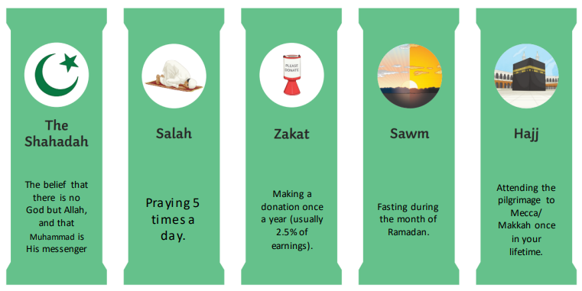
The Five Pillars of Islam
The Qur’an was revealed to the Prophet Muhammad during the month of Ramadan. Muslims perform Wudu before touching it.
