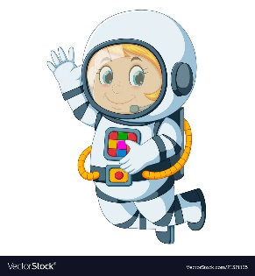
Astronaut Spellings
Week beginning 28th September
(This week we are learning ‘red’ words. These are words that contain a sound with an odd spelling. We needs to Stop and Think about the odd part of the word before we write it)
where
could
there
want
was
would
what

