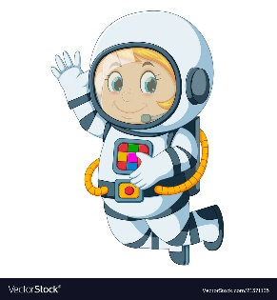
Astronaut Spellings
Week 12 29.11.21
Special focus
myth
Egypt
gym
pyramid
mystery
cymbal
cygnet

