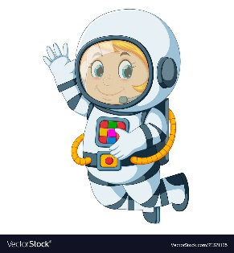
Astronaut Spellings
Week beginning 7th December
wave
wavy
spike
spiky
slime
slimy
craze
crazy
shine
shiny

