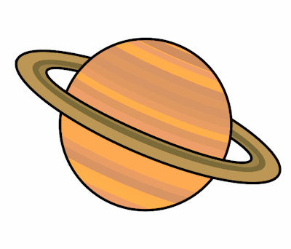
Planet Spellings
Week beginning 28th September
answer
island
February
length
strength
business
knight
knowledge
sword
wrong

