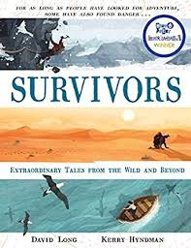
- Read from where we left off yesterday, page 22 ‘The results from Wetzel’s experiments suggested…’ to page 23 ‘…travelling in the dark to avoid being seen.’
- Think about their plan. Sometimes when we are thinking about the unknown, it is a good idea to list all the good points and bad points about it before we make a decision.
- Do this with Strelczyk’s and Wetzel’s plan – list all the pros and cons.
- Now you have completed your list – would you go ahead with the plan? Explain.

