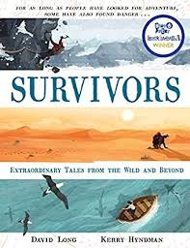
- Read from page 19, ‘The friends who crossed the border by balloon’, up to page 22, ‘…using a balloon made from even lighter fabric.’
- Why and for how long was Germany split in half?
- How were people prevented from crossing the border?
- What prompted Strelcyyk and Wetzel to come up with their plan to cross the border?
- What sort of character was Strelczyk and how do you know?
- Why does the author begin a new paragraph, page 21, ‘They decided to buy…’
- At the top of page 22, the author refers to the attempts as ‘meticulous’. What does the author mean by this?
- Which parts of the story give us the impression that the survivors might be worried about their plan?
- What are the main events that happen in each paragraph?

