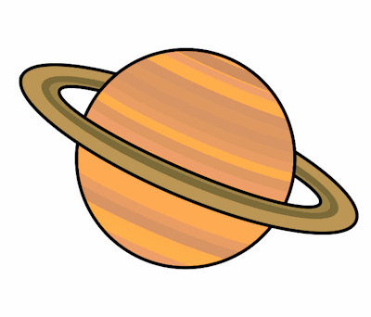
Planet Spellings
Week 7 18/10/21
grey
eight
eighteen
eighty
vein
weigh
weight
they
obey
sleigh

