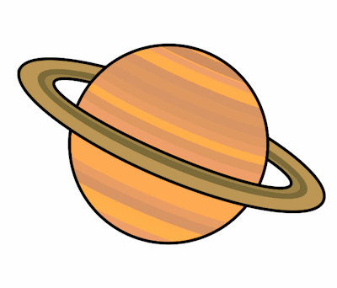
Planet Spellings
Week beginning 30th November
act
action
invent
invention
attract
attraction
correct
correction
collect
collection

