Key Learning
- I can explore ways in which religions help people to live, even when times are tough e.g. through prayer; giving a sense of purpose; a guide to deciding what is right and wrong; membership of a community or opportunities to celebrate together.
- I can describe some key concepts about life after death in Christianity (such as judgement, heaven, salvation through Jesus); and Hinduism (karma, soul, reincarnation and moksha); and a non-religious view about what happens after death e.g. Humanism.
- I can consider similarities and differences in ceremonies that mark the end of life on Earth and how these express different beliefs.
Key Vocabulary
soul
the spiritual part of a person believed to give life to the body and in many religions thought to live forever

Christian
the belief that Jesus is the Christ, or chosen one, whom God sent to the world to save humans

Hinduism
the belief in a supreme God Brahman

Humanism
the belief that it is possible to live a good and fulfilling life without following a traditional religion

reincarnation
the rebirth of the soul in one or more existences

moksha
within Hinduism, the freedom from the eternal cycle of life, death, and rebirth

judgement
to understand something, form an opinion and reach a decision

salvation
the state of being saved or protected from harm

What do religions say to us when life gets hard?
SMSC Links
Spiritual
Consider the differences in spiritual beliefs of different faiths.
Moral
Consider morals of people who live life to the fullest.
Social
Reflect on and express own ideas, concerns and possible worries about death and the idea of life and beyond.

Key Texts
Heaven – Steve Turner

Heaven – Nicholas Allen

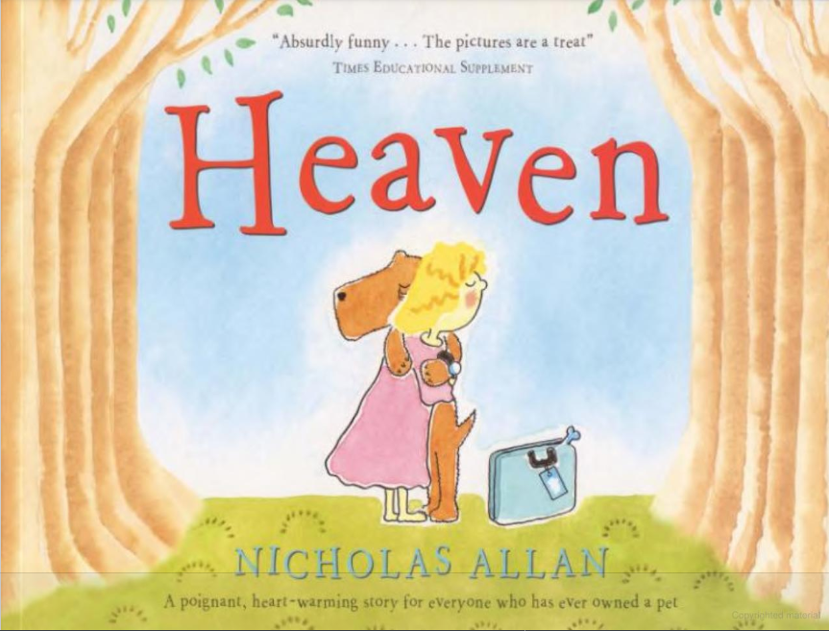
End Point
Write a letter to Lil (protagonist from Heaven), about life and death, and how religion can help when life gets hard.

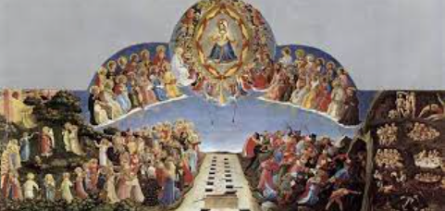
The Last Judgement

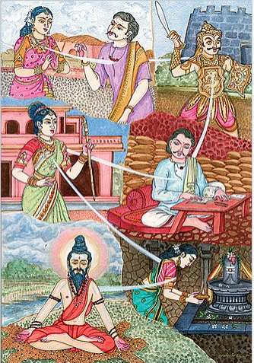
Reincarnation

