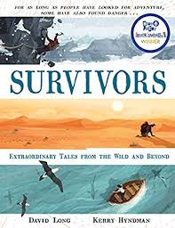
- Read from P.72, ‘By this stage in the expedition…’ up to ‘…rock-strewn ground as best he could.’
- What sort of a leader was Major Andrew Henry? How can you tell?
- Why do you think Jim Bridger and John Fitzgerald chose to stay with Glass?
- How do you think events might have unfolded if the two men had not remained with Glass?
- At the top of page 74, the author uses the word ‘ingenious’ – can you think of synonyms for this word? Why did the author choose to use this word?
- After Glass decides to head to Fort Kiowa, what do you think are the most important issues he needs to think about for his survival?
- The author uses the description, ‘rough, rock-strewn ground.’ What do you notice about the words the author has used here?

