Sea Turtle Facts
Find out some interesting facts about sea turtles.
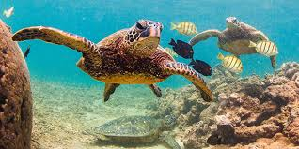

https://www.natgeokids.com/uk/discover/animals/sea-life/green-sea-turtle-facts/

