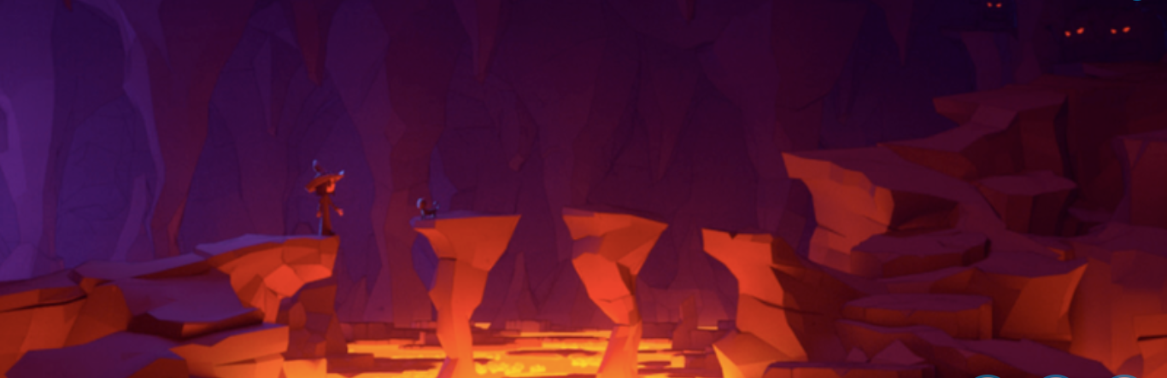

Describe what is going on in this picture. I have had a go but I definitely think it can be improved, can you help?
The cave was dark. The lava was orange. The girl and her cat went across the stepping-stones.

