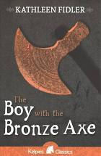
- Read page 146.
- In this part of the story Tenko is having a challenging night.
- After he got back to safety, Tenko wrote in his diary.
- What would you have written if you were Tenko?

