PSHE Knowledge Organiser
Key Knowledge | Key Vocabulary
- I can tell the difference between healthy and unhealthy foods and activities.  - I can identify what we have to do to feel well and be healthy.  - I can describe how not eating well and not being active can affect our bodies and how well we feel. | 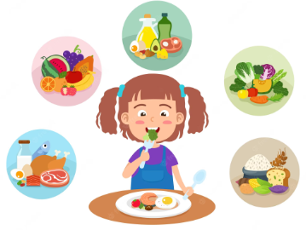  carbohydrate, protein, vitamins,  minerals, saturated fats,  unsaturated fats
- I can make informed choices about my exercise and sleep habits.  - I can identify the physical, emotional and mental consequences of not getting enough exercise or sleep.  - I can use mindfulness and meditation to aid a good night’s sleep. | 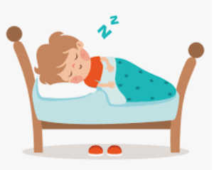  choices, consequences, sleep, deprivation, impact, effects, positive, negative, physical, emotional, mental, health, wellbeing, mindfulness, meditation, habit, routine
- I understand the need for good personal hygiene.  - I can identify healthy habits.  - I know how to protect my body in different ways. | 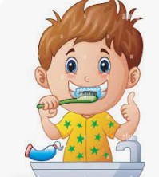  health, wellbeing, care, habits, healthy eating, diet,  exercise, physical, mental, teeth, oral, dental, body,  sun exposure, illness, bacteria, virus, germs, infection,  hygiene, medicines, allergies, responsibility
- I understand that the choices I make about my body have consequences.  - I understand what contributes to a balanced lifestyle.  - I can identify factors that influence choices we make about our bodies. | 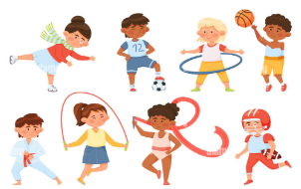  health, wellbeing, physical, mental, drugs, positive,  decision, choice, influence, balanced lifestyle,  emotional, body image, pressure, media, rest,  consent, diet, exercise, cleanliness
- I can identify what a drug is and can discuss how different drugs affect the body.  - I can suggest where pressure might come from to try drugs, including alcohol and tobacco.  - I know what to do if I feel pressured to try a harmful substance. | 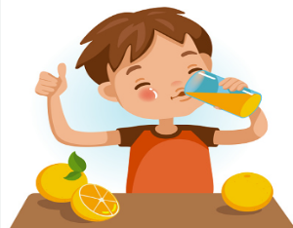  alcohol, cigarettes, tobacco, e-cigarettes,  vaping, vapes, vape pens, medicine, nicotine,  addictive, drugs, harmful, dangerous, substances,  habit, healthy, unhealthy, damage, pressure,  media, legal, illegal, age restrictions, choice,  energy drinks, caffeine
- I understand that the choices I make about my body have consequences.  - I understand what contributes to a balanced lifestyle.  - I can identify factors that influence choices we make about our bodies. | 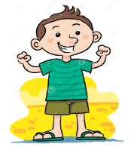  health, wellbeing, physical, mental, drugs,  positive, decision, choice, influence,  balanced lifestyle, emotional, body image,  pressure, media, rest, consent, diet, exercise,  cleanliness

