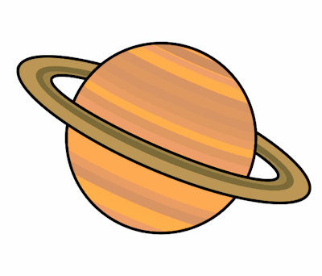
Planet Spellings
Week beginning 1st February
whether,
weather,
scene,
seen,
plain,
plane,
week,
weak,
male,
mail,
hear,
here

