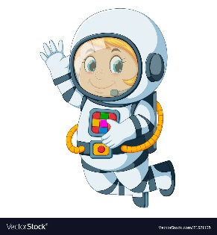
Astronaut Spellings
Week beginning 16th November
air
fair
pair
hair
chair
lair
share
care
bare

