Questions For Chapter 8
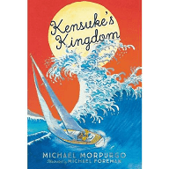
- What special thing did Michael find in the bottom of the boat? (very end of Chapter 7)
- Where was Kensuke born?
- What job did Kensuke do in Japan?
- What event caused Kensuke’s life to change?
- What did Kesuke hear on the radio?
- Why did this make him sad?
- How did Kensuke end up on the island?
- What supplies did Kensuke take from the ship?
- How did Kensuke rescue Michael?
- Why do you think Kensuke did not want to be friends with Michael?
- Why do you think Michael wrote a message to his mum and dad?

