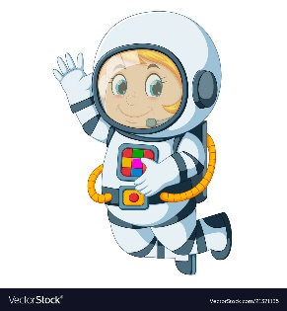
Astronaut Spellings
Week 19th July
potion
station
fiction
caption
section
nation
emotion
fraction
expedition
affection

