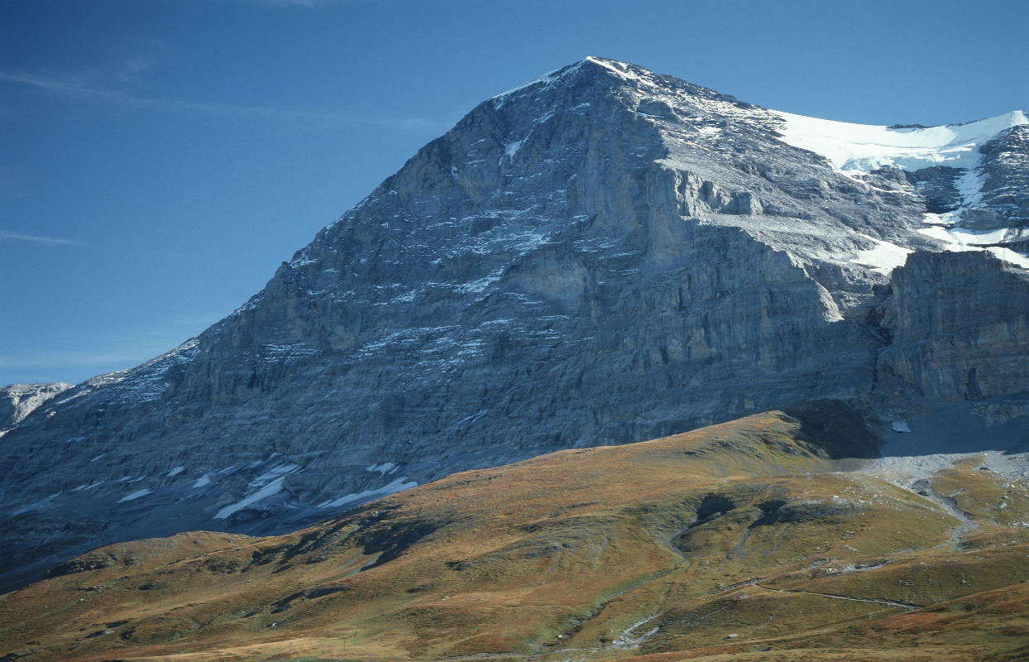
- Read from page 173, ‘Though he was now very much alone,’ to the end.
- Now watch this short clip. https://www.youtube.com/watch?v=cJk3F8G1u4A
- The Bernese authorities made it illegal at one point for anyone to attempt to climb Eiger Mountain. Imagine that you are working with them and you know of a number of climbing groups that are planning a climbing attempt.
- Your job is to create a poster advising them of why they should not make their attempt. Remember to refer to the text to explain your reasons why they shouldn’t climb.

