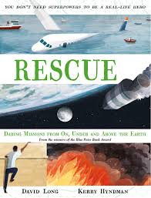
- Read ‘When a daring stunt goes wrong’.
- Imagine you are a news reporter in the crowd on the ground.
- Write a column for the newspaper telling your readers all about the event.
- Have a look at the ‘Top Tips’ to help you write a great news article.

