Self Isolation Work
Week Beginning: 19/10/2020
Year Group: Year One

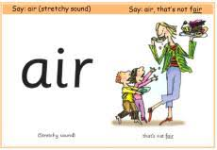
Phonics:
This weeks sounds: air
oo: that’s not fair
Practise saying the rhyme, writing the sounds in different words you can think of- but be careful, it is a
sound that can be written in multiple ways!
Extension: Can you put those words into a sentence and write it?
Can you find this sound around the house, in your reading book or a book in your home?
Spellings: Can you put these into sentences as you practise?
Hold a sentence: let me get a fat red plum. I will put you into the pond.
Adult says the sentence, children have to remember and write it, remembering their finger spaces, capital letters, full stops and correct phonics spellings.

Maths:
This weeks number blocks mathematics focus: How to Count
Number blocks video: https://www.bbc.co.uk/iplayer/episode/b08cr24d/numberblocks-series-1-how-to-count
Lesson Focus: part whole model, fact families and numberbonds
(See resources on article you found this document)

Writing:
We are really focusing on writing in cursive this week and structuring sentences.
Can you write some silly sentences from your head? Practise saying the sentence in the right order and then writing it with;
Capital letters
Full stops
Finger spaces
Cursive handwriting
Using phonics to help spelling

Can you put in in some ‘air’ words to help practise your spellings this week?

