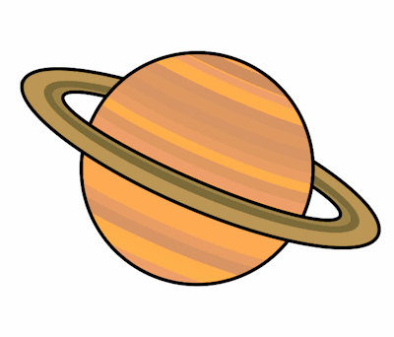
Planet Spellings
Week 9 8/11/21
science
scissors
scent
scene
ascend
descend
muscle
fascinate

