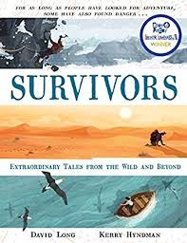
- Read page 154, ‘The conservationist who crashed in the Kalahari,’ to page 155, ‘…and heave his body across the scorched ground to a safer position.’
- What sort of territory is the Kalahari and where in the world is it located?
- Can you find in the text some interesting facts about the wild dogs in the Kalahari?
- What does the author mean by ‘reputation’ near the top of page 154? What is the reputation of the wild dogs?
- Why do you think Rasmussen needed to ‘observe the dogs moving through the park’?
- What does the author mean when he refers to the ‘sound of the highly flammable fuel leaking’ as ‘ominous’?
- What do you think Rasmussen should do first now he has managed to move to a safer position?

