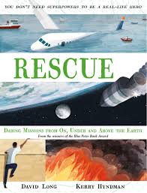
- Read from page 156, ‘A bomb inside a soldier’s body,’ to page 159, ‘…would almost certainly die from loss of blood.’
- Jared (Doc) and the other soldiers had some big decisions to make about helping their comrade, Channing Moss. What were their decisions?
- If you had been one of the crew with Channing Moss, what would you have done and why?
- Create a flow chart with two possible endings to the story depending on the decisions the crew made.
- Remember this is a real story and it is in our Rescue book so you are not allowed to say the RPG exploded and everybody was killed.

