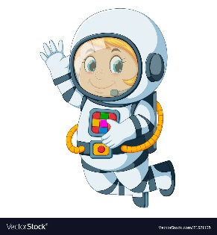
Astronaut Spellings
Week beginning 16th November
ear
near
fear
hear
dear
beard
year
tear
gear

