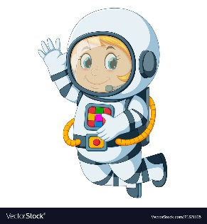
Astronaut Spellings
Week beginning 2nd November
fire
spire
wire
hire
tired
umpire
vampire
admire
retire

