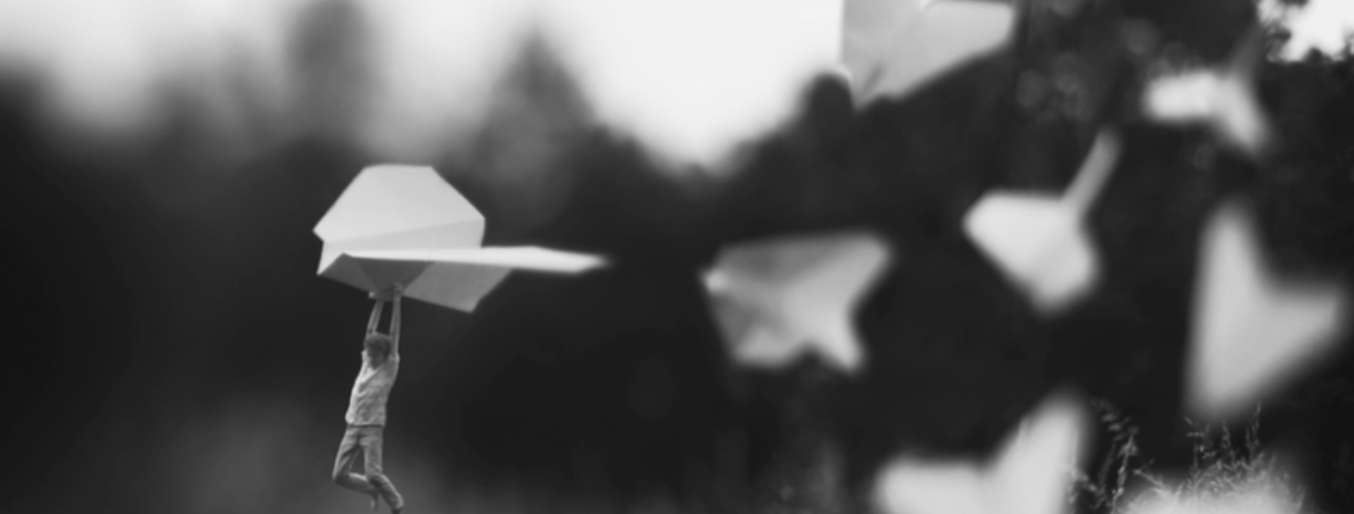

- Look at this image which is entitled ‘The Dare’.
- Now can you write a News Report about it?
- Don’t forget to include all the features we have looked at it in class.
- Most importantly, remember the five Ws.
Who? What? Why? Where? When?

