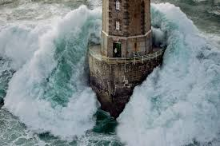
Describe this picture using five sentences. Remember not to start any in the same way.

