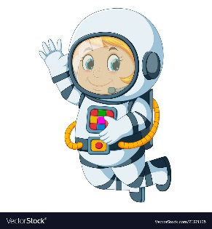
Astronaut Spellings
Week 1 4th January
Unit 10
music
musician
magic
magician
electric
electrician
optician
politician

