Dear Parents and Carers

We hope that you have all had a lovely summer holiday and that you have all had a well-deserved break. We are really looking forward to welcoming your child back into school next week.

This is just a reminder that school begins on Tuesday the 6th of September at 8.50am, the school gates will be open at 8.45am. The school day ends at 3.30pm. We ask that you ensure your child arrives at school on time in the morning as latecomers prove very disruptive to the morning lessons. We also ask that all parents, with the exception of parents of new reception children, drop their child off at the school gate, new children can be accompanied into the playground or school. Collection at the end of the day will be from the playground.

Breakfast Club (7.45am-8.50am) and Stay and Play Club (3.30pm-5.30pm) will be running as normal in the first week of term. Activity clubs will not be running until the second week of term; information regarding these clubs will be sent out during the first week back.

School dinners will be cooked as normal and the September menu is on the school news page (the menu changes – September).

Please could your child be dressed in the correct school uniform (listed on the school website-About page) and please could you ensure that they bring their PE kits and water bottles into school to keep in their locker Mon-Fri. If the warm, sunny weather continues they will need a sun hat and sun-cream in their school bags.

REMINDER FONSS UNIFORM RECYCLING PROJECT.
PLEASE SEE BELOW

Kindest Regards
Louise Wallen
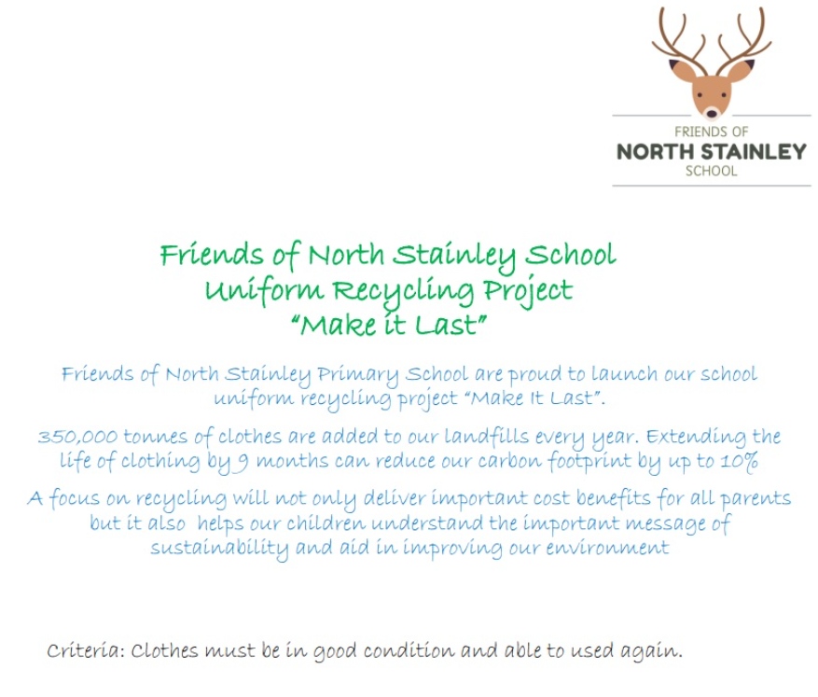

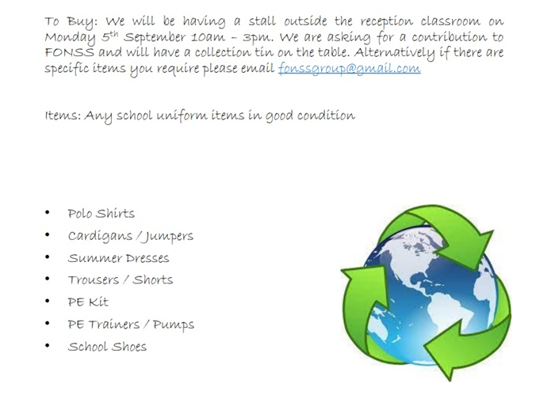

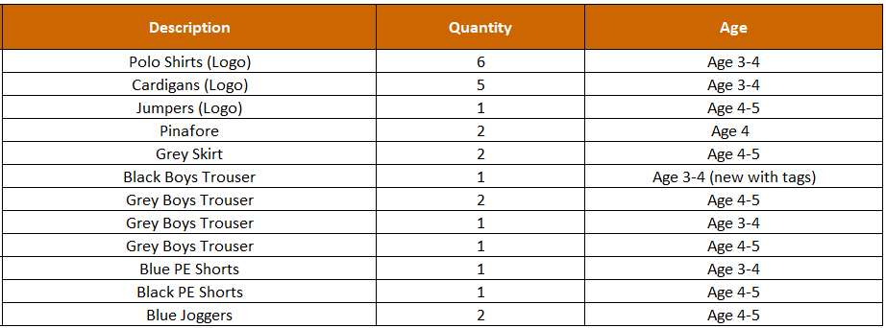

Some of the uniform collected so far….

