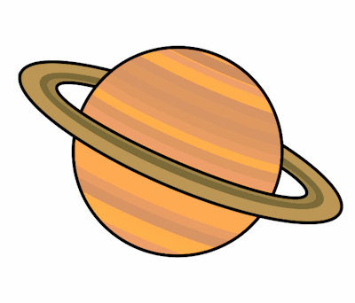
Planet Spellings
Week 2 27/9/21
automobile
autograph
automatic
autopilot
though
although
thought
through
threw
therefore

