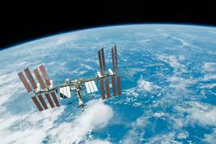
This weekend I have been tuning in to the launch of Falcon 9 (very exciting). I wonder if you were following it.
Why was it such an historic event?
What exactly happened?
Who was involved?

