Key Vocabulary
Tropical grassland or savannah  Within the tropics.  Hot with a wet and dry season.  Mainly grass and a few specially adapted trees. | Tropical rainforest  Hot and wet all year.  Rich in plants and animals.  Poor soils.
Desert  Can be hot or cold.  Limited plants. | Tundra  Below freezing for most of the year.  Ground permanently frozen.
Deciduous forest  Cool summers and mild winters.  Rain throughout the year.  Rich deciduous woodland. | Coniferous forest (Taiga)  Long, cold winters.  Short, mild summer.  Limited rainfall.
Temperate grassland  Warm summer and very cold winter.  Quite low rainfall.  Mainly grassland vegetation. | 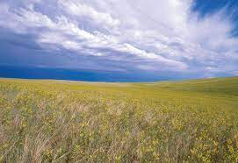
Biomes Knowledge Organiser
Key Vocabulary
biome | large ecosystem which relies on climate
equator | imaginary line halfway around the earth which is between the North and South Poles.
latitude | lines which go around the earth east to west
longitude | lines which go around the earth north to south
hemisphere | half of the earth (northern or southern)
climate | average weather conditions over longer periods
precipitation | any form of moisture which falls to the earth
ecosystem | group of living organisms interacting with their physical environment
biodiversity | variety of living things e.g. species, habitats
flora | another word to refer to plants
fauna | another word to refer to animals
savannah | type of biome. Sometimes called tropical grass
tundra | type of biome. The coldest biome.
coniferous forest | forests made mostly of conifer trees such as cedar, fir and pine trees.
deciduous forest | forests made mostly of broad-leafed trees that shed their leaves during a season (usually winter)
