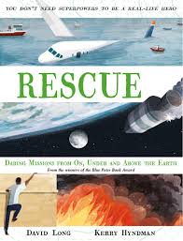
- Read page 134, ‘Houston, we’ve had a problem,’ to page 136, ‘…while the flight controllers worked out what to do next.’
- How many people have actually walked on the moon?
- The astronauts flew to the Moon in Saturn V rockets. Find 5 facts about these rockets.
- What sort of person do you think makes a good astronaut? Why? (Remember to refer to the text.)
- What caused the loud bang the three astronauts heard?
- Why did it look like the mission was going to turn into a disaster?
- What plan did the astronauts decide to follow after reporting their ‘problem’ to mission control? Why did they think this might be a good solution?

