Make A Sea Turtle
Look at some of these ideas to make a sea turtle. See if you can make your own.
Paint rocks or pebbles:
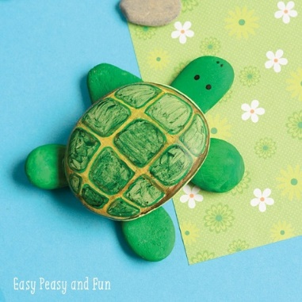
Use an egg box:
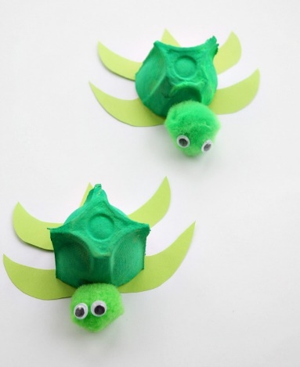
Use a soft drinks bottle:
