Self Isolation Work
Week Beginning: 05/10/2020
Year Group: Year One

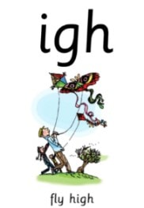
Phonics:
This weeks sounds: igh
igh: Fly high
Practise saying the rhyme, writing the sounds in different words you can think of- but be careful, it is a
sound that can be written in multiple ways!
Extension: Can you put that words into a sentence and write it?
Can you find this sound around the house, in your book or a book in your home?
Spellings: Can you put these into sentences as you practise?
Hold a sentence: I flew so high I touched the moon.
Adult says the sentence, children have to remember and write it, remembering their finger spaces, capital letters, full stops and correct phonics spellings.

Maths:
This weeks number blocks mathematics focus: Three
Number blocks video: https://www.bbc.co.uk/iplayer/episode/b08bzgxx/numberblocks-series-1-three
Lesson Focus: Counting backwards, counting one more and one less, comparing objects
(See resources on article you found this document)

Writing:
We have been practising talk for writing- ask you children to demonstrate what this is!

Can they put these sentences into talk for writing words and symbols and then draw a picture of what the sentence is about? I have done an example for you.
- The sun smiled when the rain stopped.
- A cow flew over the pyramids in Egypt.
- The rainbow was colourful and big.
- A superhero always wears a cape.
- The alien span off Planet Zog and landed on a car.
Extension: Can you add any words to the sentences in
a different colour to make them sound even better?
very huge red hot spotty shiny silly tiny

