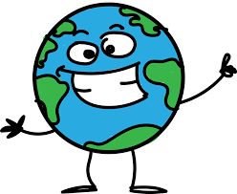

- Over the last few days we have been thinking about ensuring that everybody has equal access to the world’s resources.
- Are there any small changes you could make – both at home and at school?
- If you could set up a charity to help equal access to the world’s resources – what would it be and how would it help?
- You can present your work how you choose e.g. a leaflet, a poster or you could even send a video in through Teams.

